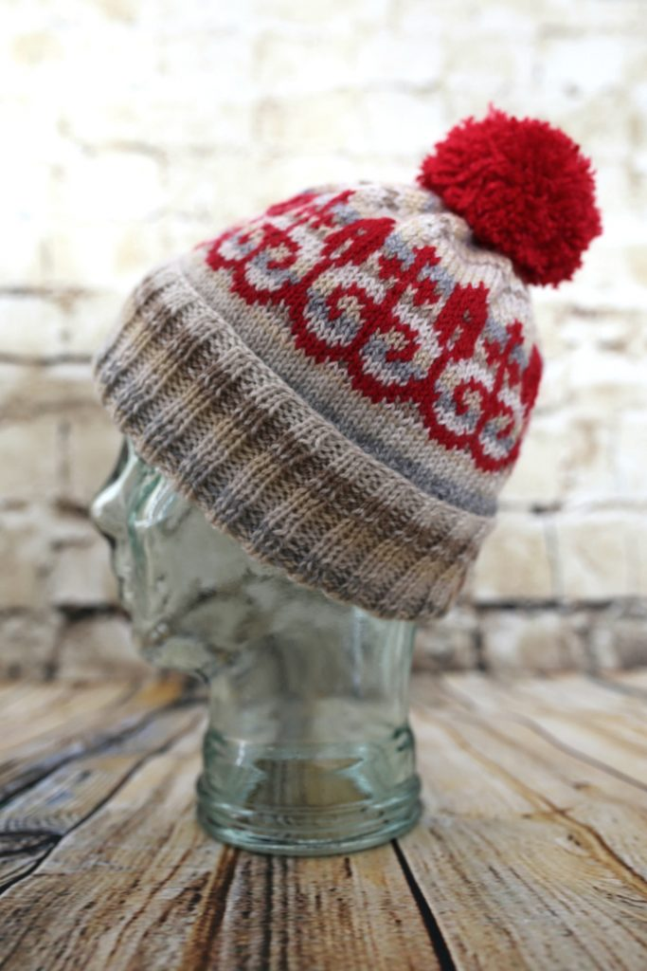
The Elisabeth Hat
By Phil at thetwistedyarn.com
My mum asked me to knit her a hat. She and I couldn’t find any suitable patterns, so I set out to design something special. This is the result. The pattern will fit a medium to large adult head.
Yarn
- Stylecraft Special DK, one ball of each of Parchment (1218), Stone (1710), Mocha (1064), and Silver (1203), OR one 100g (3.5oz) ball of your favourite variegated cream-coloured yarn of the same weight.
- Stylecraft Special DK, one ball of Lipstick (1246), for the red colourwork and pom-pom.
Equipment
- 3.5mm (US size 4) circular needles, 40cm / 16” in length.
- 4mm (US size 6) circular needles, 40cm / 16” in length.
- Set of 4mm (US size 6) double-pointed needles.
- Stitch marker.
- Darning needle.
- Medium-size pom-pom maker.
Gauge
22 sts/28 rows to 10cm²/4 inches², in stockinette on 4mm (US size 6) needles, worked in the round.
Abbreviations
k = knit. sts = stitches.
p = purl. k2tog = Knit two together to decrease.
IMPORTANT NOTE. The following pattern details refer to ‘cream’ yarn and ‘red’ yarn, for simplicity. If you are using the four pale shades of Stylecraft Special DK (Parchment, Stone, Mocha, and Silver), then swap these in and out at the start of rounds, in narrow but irregular stripes, each between one and three rounds wide. Vary the order in which the colours occur. If you would like inspiration, then a suggested sequence is provided at the end of this pattern. There is no need to cut these yarns when you change colour, as long as there is not a very large gap between occurrences of any one shade. Instead, run the inactive colours up inside the hat as vertical floats.
Instructions
1. Using 3.5mm (US size 4) needles and cream yarn (see ‘important note’ above), cast on 112 stitches. Place stitch marker, then join in the round, being careful not to twist.
2. (k2, p2) around. Slip marker.
3. Repeat previous round until you have created a band of ribbing that is 15cm (6”) wide.
4. Change to 4mm (US size 6) circular needles. Continuing in cream, work five rounds of k.
5. You will now begin working from the chart, using red yarn for the motif, and continuing in cream for the background. The chart is 14 sts wide, so each row must be repeated 8 times to complete all 112 sts of the round. In order to reduce the slight ‘jog’ in the pattern motif that occurs as you begin a new round, I recommend working the last stitch of every charted round slightly loose, and knitting the first stitch of every round slightly tight. This will reduce the difference in height between the two stitches. Work always from right to left on the chart, beginning at the bottom and working upwards until you have completed row 18. Cut red yarn. You will now work a series of decreases: change to 4mm double-pointed needles when the work becomes too tight on your circular needles.
6. Continuing in cream, k9, k2tog, k49, k2tog, k to end of round. (110)
7. k one round.
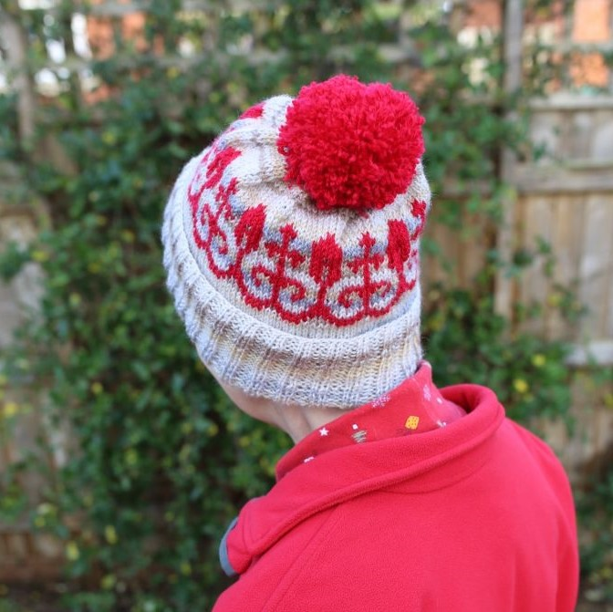
8. (k8, k2tog) around. (99)
9. k one round.
10. (k7, k2tog) around. (88)
11. k one round.
12. (k6, k2tog) around. (77)
13. k one round.
14. (k5, k2tog) around. (66)
15. k one round.
16. (k4, k2tog) around. (55)
17. k one round.
18. (k3, k2tog) around. (44)
19. k one round.
20. (k2, k2tog) around. (33)
21. (k1, k2tog) around. (22)
22. k2tog around. (11)
23. k2tog five times, then k1. (6)
24. Cut the yarn and thread a darning needle with the loose end. Sew through remaining stitches and pull the hole closed. Weave in ends. Using red yarn, make a pom-pom and sew this to the top of the hat.
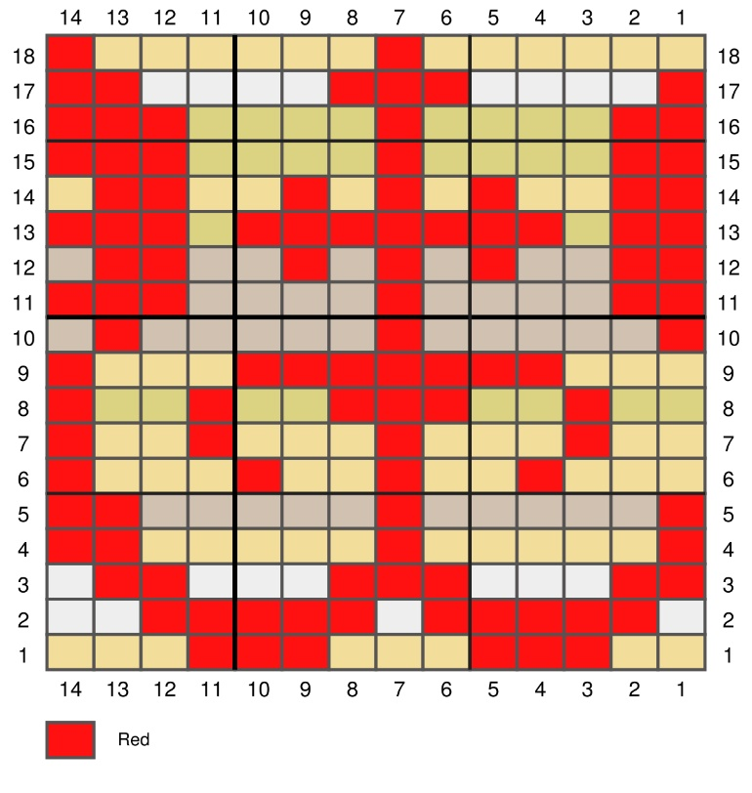
Chart for colourwork

Suggested sequence of shades to create variegated cream background
P=Parchment, St=Stone, M=Mocha, Si=Silver. Cast on in St, then work rounds in the following sequence: P, P, P, M, M, P, M, St, St, St, P, P, P, Si, Si, P, Si, St, St, P, P, P, M, M, P, M, M, Si, P, P, St, P, St, P, Si, Si, Si, M, P, P, M, M, P, Si, St, P, P, P, St, P, M, M, P, P, Si, Si, St, St, P, P, P, M, P, P, M, Si, Si, St, St, St, P, P, P, M, P, St, St, St, Si, M, M…

